21. Develop a system using UML for Hospital Management System. The central system should manage patients’ and doctors’ appointments and case details. Also, include medical prescriptions and consultation fee details.

CLASS DIAGRAM:

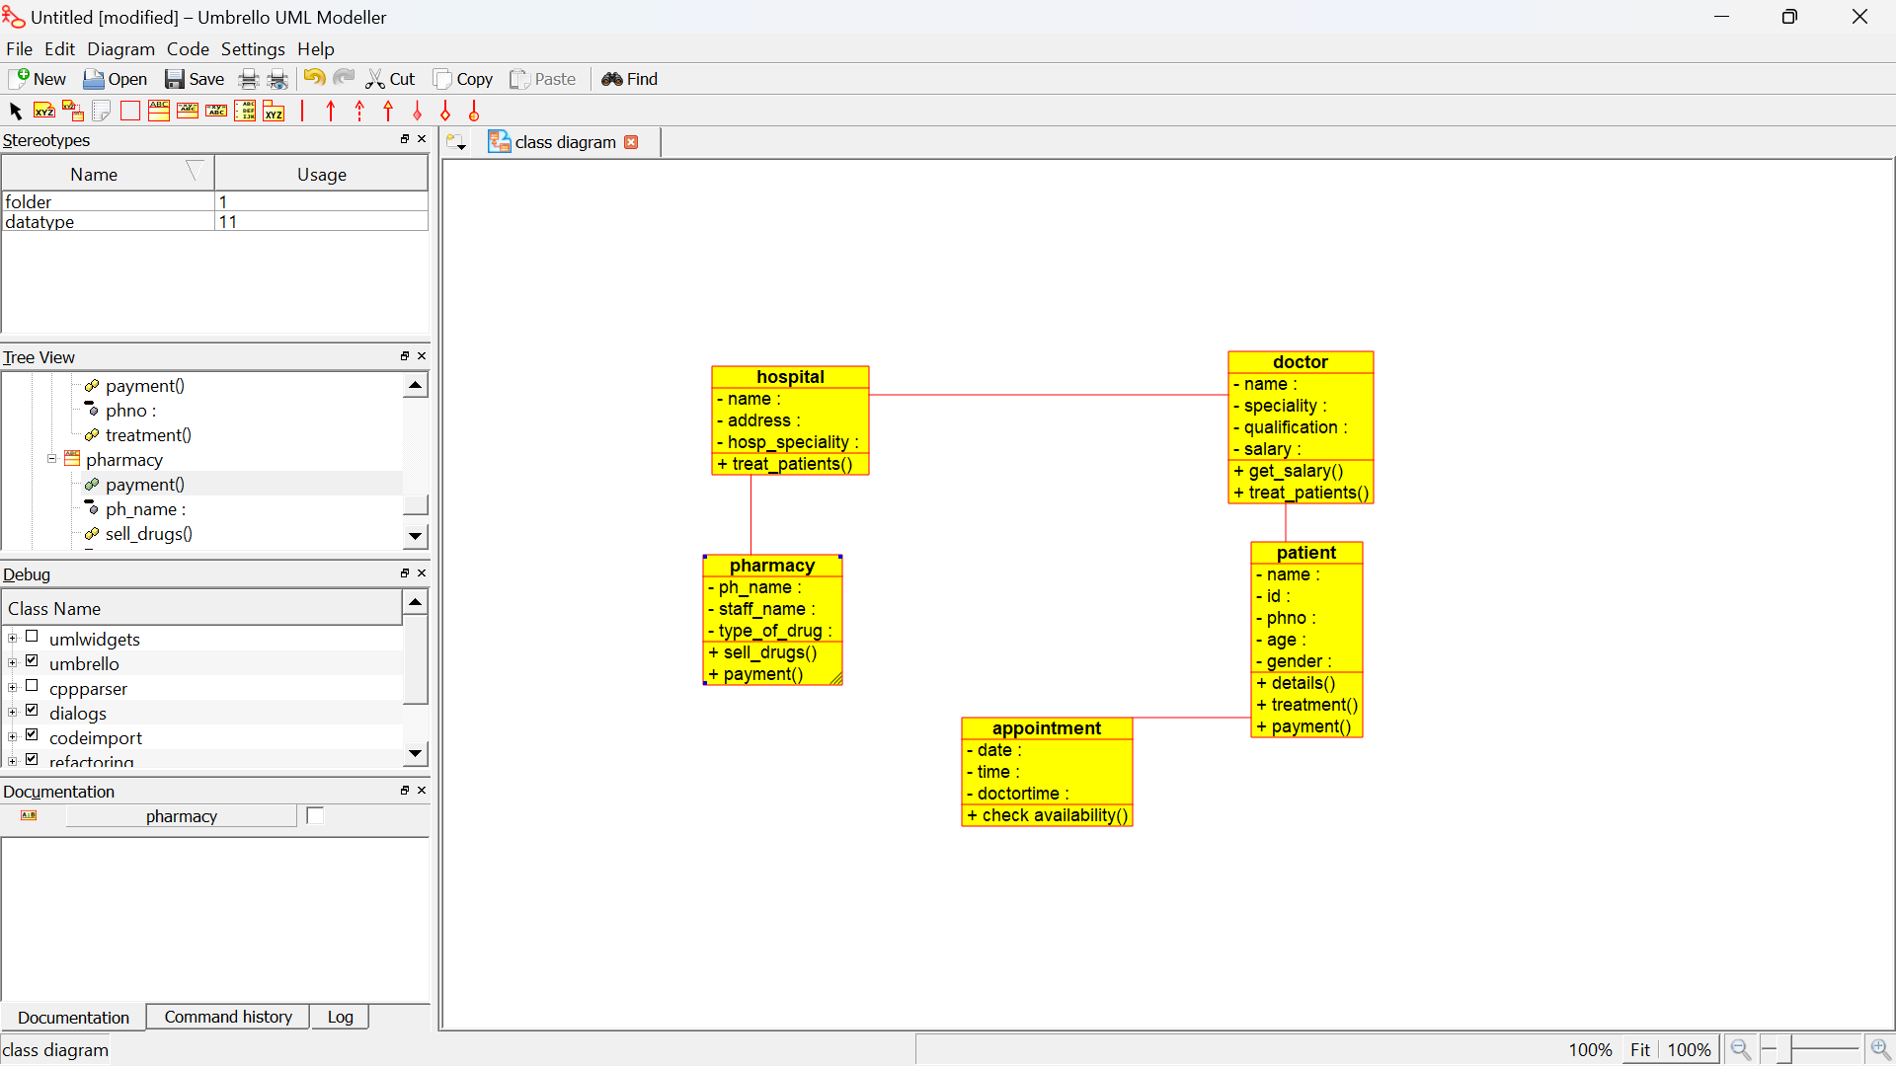

PACKAGE DIAGRAM:

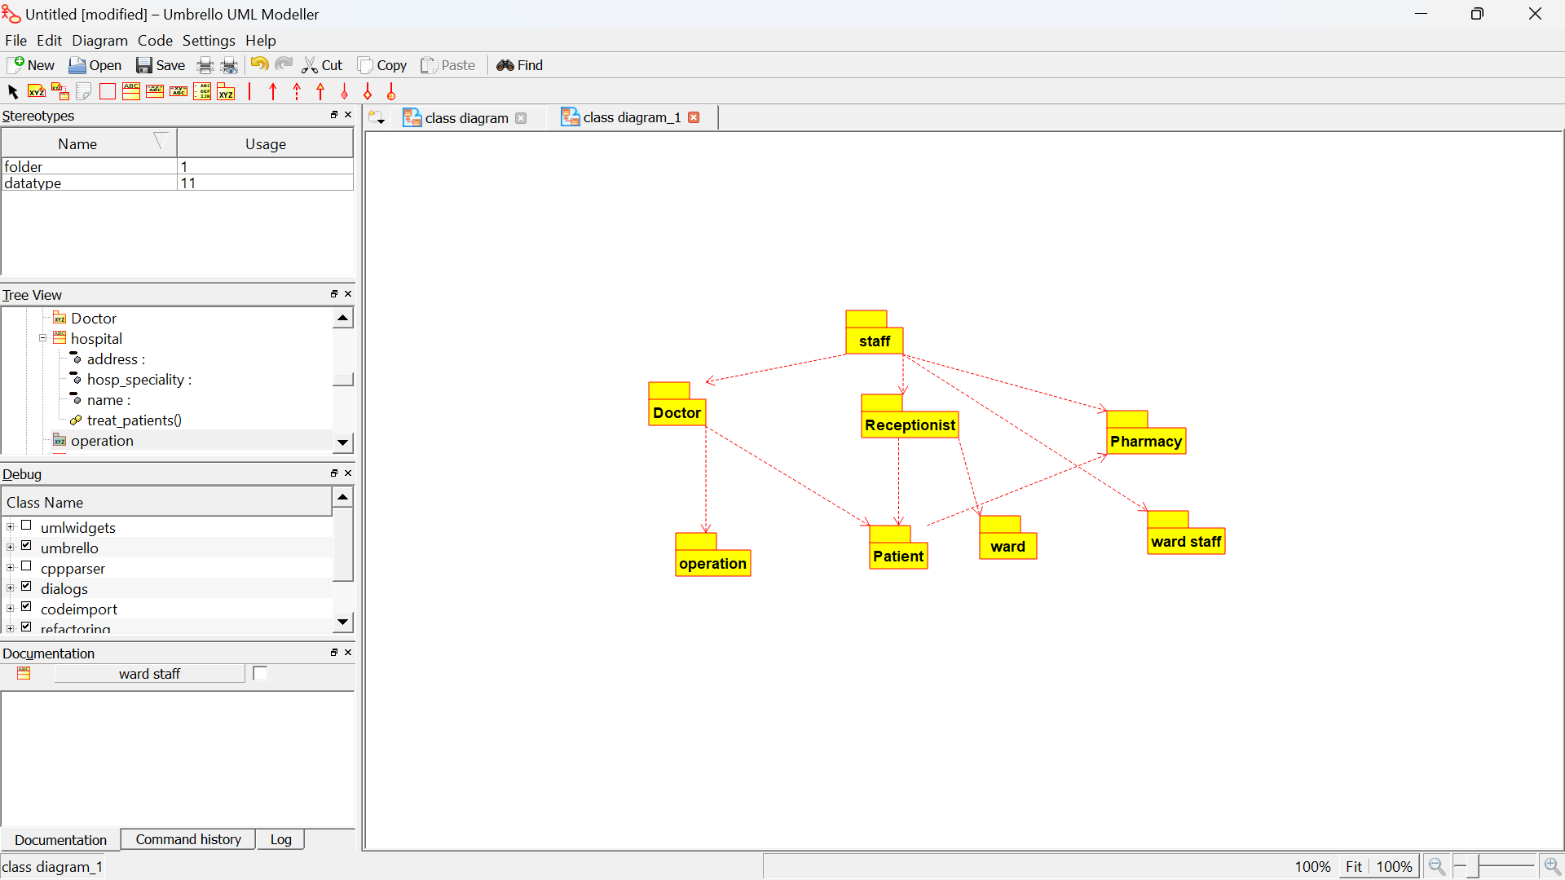

DEPLOYMENT DIAGRAM:

